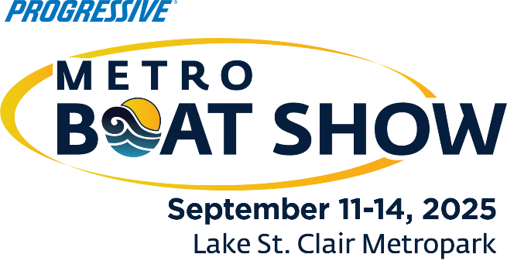**For Immediate Release**

**Contact:** Nicki Polan, Executive Director  
P: 734.261.0123, ext. 4 – E: npolan@mbia.org  
  
Amanda Wendecker, VP of Marketing  
P: 734.261.0123, ext. 3 – E: awendecker@mbia.org

**2025 Progressive® Metro Boat Show deemed a success!**

**Commerce Twp., Mich., September 16, 2025** – The Progressive® Metro Boat Show, held September 11-14 at the Lake St. Clair Metropark was deemed a success by producer Michigan Boating Industries Association, exhibitors, sponsors, and attendees. More than 8,500 attendees strolled the walkways of the Shore and South marinas at the Metropark.

“This show is a significant boating event, being the largest in-water boat show in the region, spanning nearly a 1-mile footprint with hundreds of boats of all types and all sizes to see and purchase,” said Show Manager Nicki Polan. “Many don’t realize that Michigan is the third largest marine market in the country! Boating is big business in Michigan and this event has a big impact on this region.”

“The beautiful weekend weather was perfect for the show! It was great to see thousands of consumers who attended to see the display of hundreds of boats and enjoy the show atmosphere with beer tents, live music and fun, making it one of our favorite events of the year,” said Amy Crouchman of Walstrom Marine and MBIA Board Chair.

The National Marine Manufacturers Association reports that the total economic impact of recreational boating in Michigan is a staggering $11.7 billion annually! This is up 82% since the same study in 2018. The recreational boating industry in Michigan supports 1,500 business and 58,000 jobs in the industry.

The Progressive® Metro Boat Show is produced by the Michigan Boating Industries Association (MBIA). Save the date for 2026 show, September 17-20. For more information, visit Metroboatshow.net. The MBIA also produces the Progressive® Detroit Boat Show which will take place in a new location February 12-15, 2026 at the Suburban Collection Showplace, and the Progressive® Novi Boat Show March 12-15, 2026 at Suburban Collection Showplace. Proceeds from MBIA boat shows are returned to the boating industry through MBIA programs and services. For more information, visit mbia.org.

###

***The Voice of Boating in Michigan***Michigan Boating Industries Association, 8625 Richardson Road, Commerce Twp., MI 48390  
P: 734.261.0123, F: 734.261.0880, E: boatmichigan@mbia.org