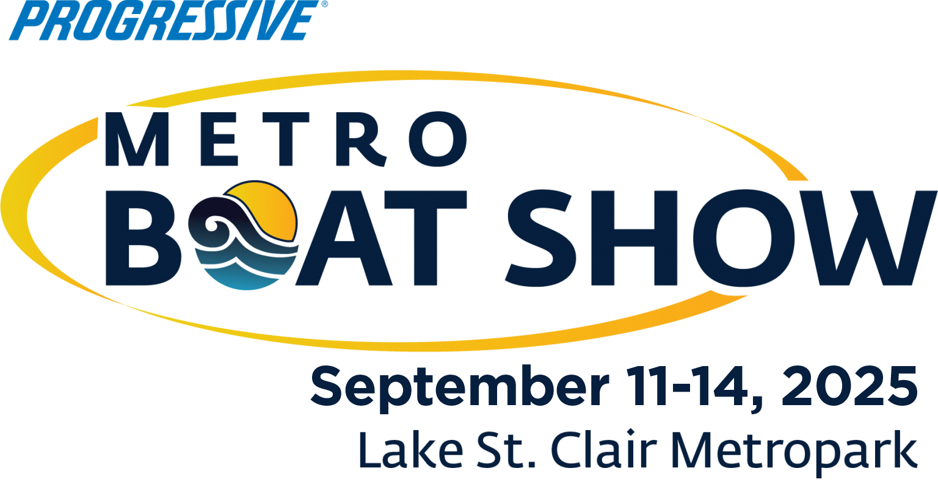
For Immediate Release
Contact: Nicki Polan, Executive Director
P: 734.261.0123, ext. 4 – E: npolan@mbia.org
Amanda Wendecker, VP of Marketing
P: 734.261.0123, ext. 3 – E: awendecker@mbia.org
Discover Boating and more at the Progressive® Metro Boat Show
Commerce Twp., Mich., August 13, 2025 - Mark your calendar! The sixteenth annual Progressive® Metro Boat Show, the largest in-water boat show in the Midwest spanning a mile long footprint, is coming to Lake St. Clair Metropark September 11-14 with boats up to 50 ft.+ in length on display and for sale.
A boat show is the best way to shop and compare hundreds of boats in one place and also learn more about boating and the boating lifestyle. Being immersed into a marina setting with a picturesque boardwalk lined with beautiful boats along the coast of Lake St. Clair make this show such a joy to attend.
Boats featured include new and previously owned fishing boats, cruisers, yachts, pontoon boats, personal watercraft, canoes, kayaks, and paddleboards. The show is a great place to get a first look at the new 2026 model introductions, and for end-of-season deals from quality yacht brokers and dealers. It is also a great place to learn more about boating, and just to have some fun.
Promotions include a variety of food trucks, beer tents; kids’ crafts, and more - providing hours of entertainment for the whole family. Local Bands scheduled to perform include Two Dudes in Flip Flops, The Beach Katz, The Pool Boys, and Ron Devon. Shop from booths of young entrepreneurs from Young Business Owners on Saturday from 11am to 2 pm. Receive a free t-shirt (while supplies last) when you share the message of #CleanDrainDry on social media to stop the spread of Aquatic Invasive Species in our Michigan waters.
Michigan is the third largest marine market in the country, with an $11.7 billion annual impact to Michigan’s economy. Conservative estimates say four million people in Michigan enjoy the sport each year. Boating is a popular recreational pastime for Michiganders, and the Progressive® Metro Boat Show is a terrific place to experience a day near the water among boats and boating enthusiasts!
The Progressive® Metro Boat Show is produced by the Michigan Boating Industries Association (MBIA). The show, located at Lake St. Clair Metropark, will be held September 12-15, 2024. Hours: Thurs., Fri.: 1 p.m. – 7:30PM, Sat.: 11AM – 7:30PM and Sun.: 11AM – 6PM. For more information and current promotions visit metroboatshow.net. Admission: $10 for adults, children 12 and under free with an adult. Parking is $10 – or free to those with a Metroparks permit. General Park information can be found at metroparks.com or by calling 1-800-47-PARKS. Limited transient boating is available, contact the Metropark for booking dockage.
The Progressive® Metro Boat Show is sponsored by Progressive Insurance, the Huron Clinton Metroparks and Great Lakes Scuttlebutt, the official publication of MBIA Boat Shows.
###
The Voice of Boating in Michigan
Michigan Boating Industries Association, 8625 Richardson Rd., Commerce Twp., MI 48390
P: 734.261.0123, F: 734.261.0880, E: boatmichigan@mbia.org

