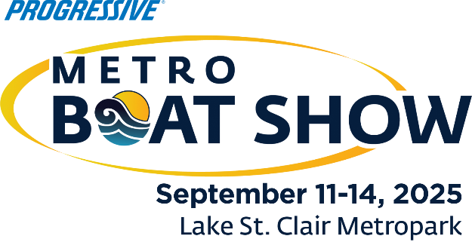
Contact: Nicki Polan, Executive Director
P: 734.261.0123, ext. 4 – E: npolan@mbia.org
Amanda Wendecker, VP of Marketing
P: 734.261.0123, ext. 3 – E: awendecker@mbia.org

Progressive® Metro Boat Show Facts
What: 16th annual Progressive Metro Boat Show
Owned and produced by Michigan Boating Industries Association

When: September 11-14, 2025

Where: Lake St. Clair Metropark, Harrison Township, Michigan
Featuring: Be immersed into the boating lifestyle at the Progressive® Metro Boat Show, with a beautiful display of boats in water and on land to see and purchase from 10 to 50+ feet in length for all interests and for all budgets. Catch great end-of-season deals and sneak peaks at the 2026 new models being introduced!

See the latest engineering, design, materials, and colors of all types and sizes: sleek yachts, runabouts, personal watercraft, pontoons, fishing boats, ski boats, inflatables, cabin cruisers and used boats. Also featured will be the latest services, accessories, engines, trailers, electronics, fishing gear, dockage, marinas, and more.

One-stop-shopping: On-site financing, insurance, slip rental, brokerage, vacation planning, charter trips, maintenance and most all other types of extras needed by boaters – saving shoppers time and money.

Feature Attractions include:
- Live music line-up
- Food trucks
- Yard games
- Beer tents
- Kids Zone with take-home crafts
- Free t-shirt giveaway (while supplies last)
- Find full list of Highlights on metroboatshow.net.

Hours: Thursday & Friday: 1 p.m. – 7:30 p.m.; Saturday: 11 a.m. – 7:30 p.m.; Sunday: 11 a.m. – 6 p.m.

Admission: Tickets available online only at metroboatshow.net - Adults $10, Children 12 and under are free with an adult.

Parking: Located at Lake St. Clair Metropark - $10 daily or free with seasonal pass.

For More Info: Go to www.metroboatshow.net or call the MBIA at 734-261-0123.

Sponsored by: Progressive Insurance, the Huron Clinton Metroparks, and Great Lakes Scuttlebutt - the official publication of MBIA Boat Shows.

###

